CS 255 System Design Document Template

UML Diagrams

UML Use Case Diagram
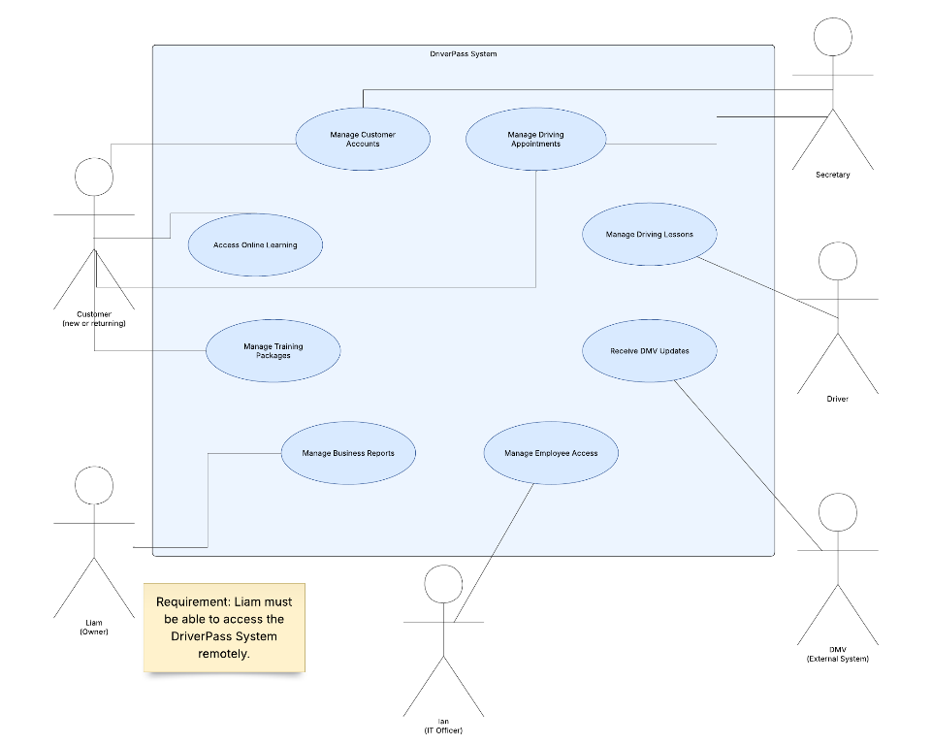
UML use case diagram showing the DriverPass system and its six actors: Customer, Secretary, Driver, Liam (Owner), Ian (IT Officer), and DMV (External System). Eight use cases represent customer account management, driving appointment scheduling, online learning, training packages, driving lessons, DMV updates, business reporting, and employee access management. Association lines connect each actor to their corresponding system functions.

UML Activity Diagrams

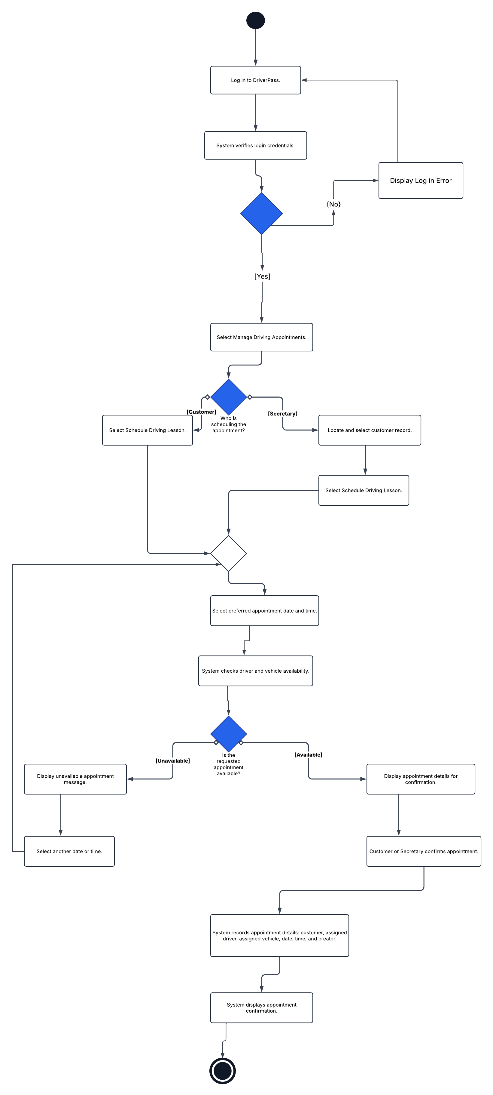
UML activity diagram illustrating the process of scheduling a DriverPass driving appointment. The customer or secretary logs in, selects the scheduling function, and chooses a preferred date and time. The system checks driver and vehicle availability. If the appointment is unavailable, another time can be selected. If available, the appointment is confirmed, its details are recorded, and a confirmation is displayed.

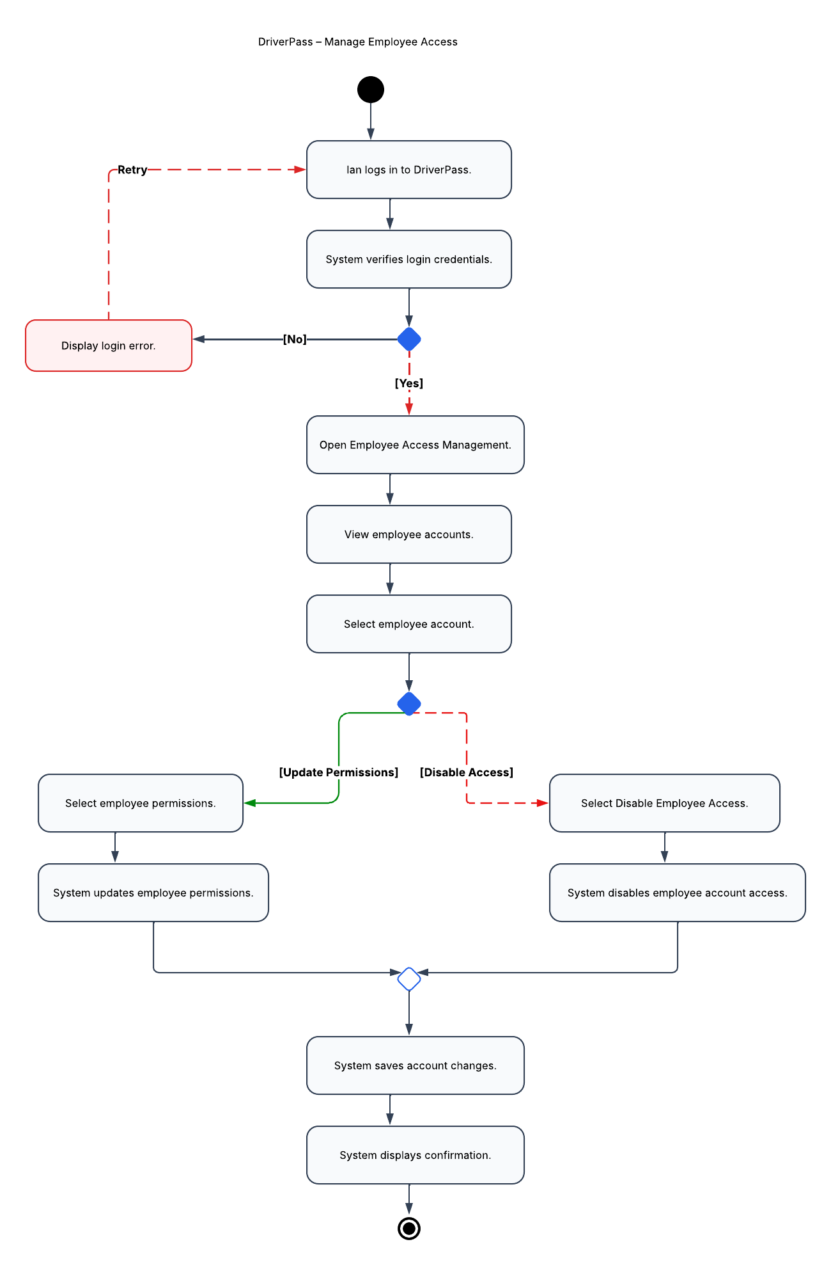
UML activity diagram showing how Ian, the IT Officer, manages employee access. After logging in and passing credential verification, Ian opens employee access management and selects an employee account. He can update the employee's permissions or disable their access. Both paths lead to the system saving the changes and displaying confirmation. An unsuccessful login produces an error and allows another attempt.

UML Sequence Diagram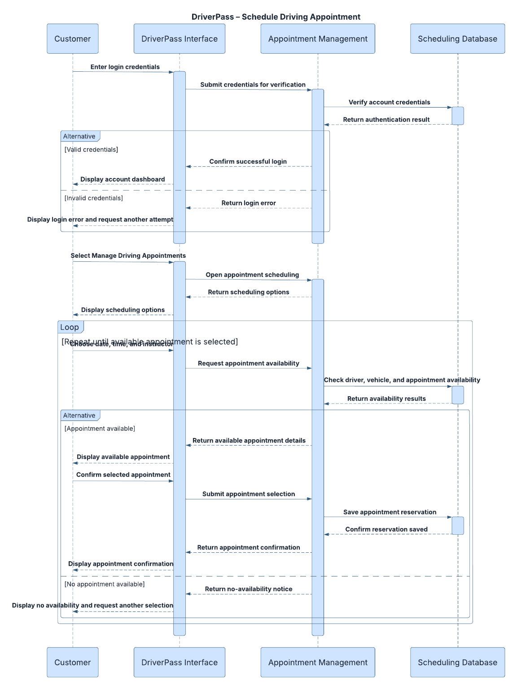
UML sequence diagram showing interactions between the Customer, DriverPass Interface, Appointment Management, and Scheduling Database. The sequence begins with login verification, followed by the customer opening appointment scheduling and selecting a date, time, and instructor. The system checks appointment availability through the database. Available appointments can be confirmed and saved, while unavailable appointments prompt the customer to make another selection.

UML Class Diagram
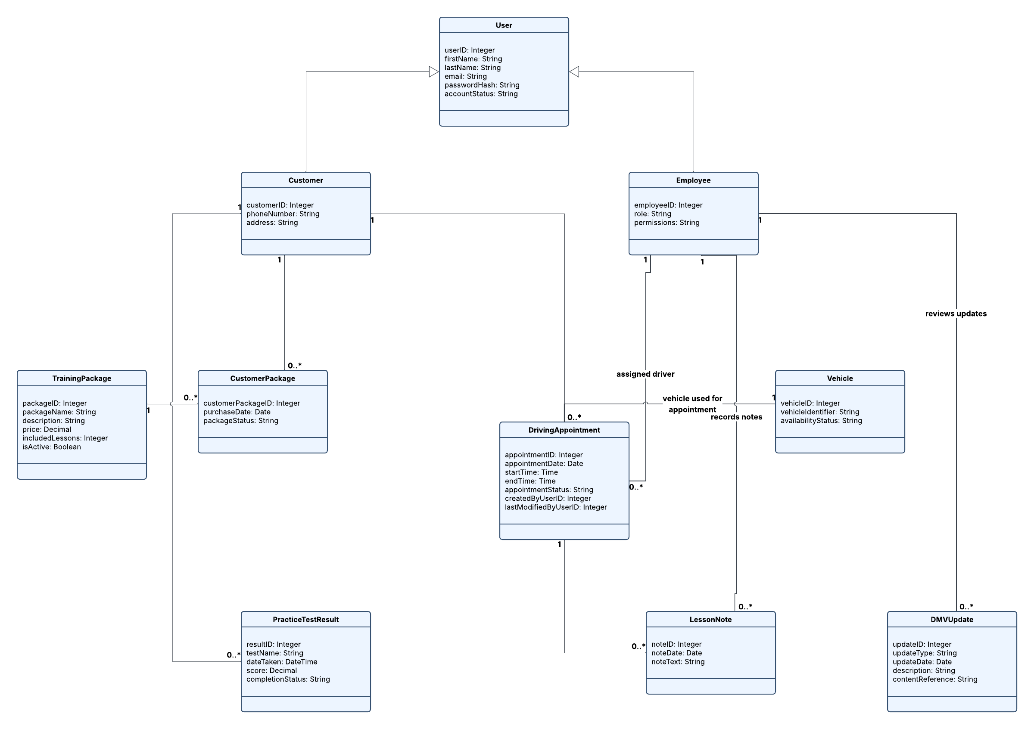

UML class diagram displaying ten classes: User, Customer, Employee, TrainingPackage, CustomerPackage, DrivingAppointment, Vehicle, PracticeTestResult, LessonNote, and DMVUpdate. Customer and Employee inherit shared account attributes from User. Associations and multiplicities describe how customers purchase packages, schedule appointments, and complete practice tests; how employees are assigned to appointments, record lesson notes, and review DMV updates; and how vehicles are associated with driving appointments.

Technical Requirements
Technical Requirements

The DriverPass system will require hardware, software, and network infrastructure capable of supporting online learning, driving appointment scheduling, customer account management, and employee operations. Because DriverPass needs to be accessible remotely, a cloud-based web application would be an appropriate solution. This would allow customers, employees, and the business owner to access the system through an internet connection without requiring DriverPass to maintain its own physical servers.

Hardware Requirements

DriverPass employees will need computers or other internet-enabled devices to access customer information, manage driving appointments, update records, and perform administrative tasks. Customers should be able to access the system using personal computers, tablets, or smartphones. The cloud hosting provider will supply the server hardware needed to operate the application and store its data. Reliable internet connectivity will be necessary for both employees and customers.

Software Requirements

The system will require a web-based application compatible with modern browsers. A centralized database will store customer accounts, employee information, training packages, driving appointments, vehicle assignments, lesson notes, and practice test results. The application must support account authentication, role-based permissions, and secure password storage. It must also provide appointment availability checks to prevent scheduling conflicts involving drivers and vehicles. The system should support updates to learning materials and testing information when DMV requirements change.

Tools and Infrastructure Requirements

Development and maintenance will require programming tools, database management tools, version control, and testing tools to ensure the application functions correctly. The system will need cloud hosting, secure network connections, and an integration method for receiving DMV information. HTTPS encryption should protect information transmitted between users and the application. Automated backups and recovery procedures will help prevent data loss and support continued business operations.

Security and Accessibility Requirements

Because DriverPass will store personal customer information and employee records, the system must restrict access according to each user's responsibilities. Customers should only access their own information, while employees receive permissions appropriate to their assigned roles. The IT Officer must be able to manage employee accounts, reset access credentials, and disable accounts when necessary. The application should also provide a clear, accessible interface that supports users with different levels of technical experience and works across common devices.

Together, these technical requirements support DriverPass's need for a secure, reliable, and accessible system that manages driving instruction services while allowing the business to operate efficiently and accommodate future growth.

